
St. Leonard’s CE Primary School
Addition Policy

MENTAL CALCULATIONS

These are a selection of the mental calculation strategies for addition that we use at St. Leonard’s:

Mental recall of number bonds
6 + 4 = 10 + 3 = 10
25 + 75 = 100 19 + = 20

Use near doubles
6 + 7 = double 6 + 1 = 13

Addition using partitioning and recombining
34 + 45 = (30 + 40) + (4 + 5) = 79

Counting on in repeated steps of 1, 10, 100, 1000
86 + 57 = 143 (by counting on in tens and then in ones)

Add the nearest multiple of 10, 100 and 1000 and adjust
24 + 19 = 24 + 20 – 1 = 43
458 + 71 = 458 + 70 + 1 = 529

Use the relationship between addition and subtraction
36 + 19 = 55 19 + 36 = 55
55 – 19 = 36 55 – 36 = 19

MANY MENTAL CALCULATION STRATEGIES WILL CONTINUE TO BE USED. THEY ARE NOT REPLACED BY WRITTEN METHODS.

ADDITION
YR and Y1
Pictures
Children are encouraged to develop a mental picture of the number system in their heads to use for calculation. They develop ways of recording calculations using pictures, etc.

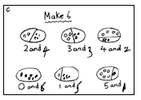
Rekenreks
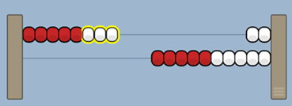
Children use rekenreks to support the addition of numbers.
Base Ten
Children will use base ten to build numbers and add these together. They will start by using physical resources and then start to draw the representations when they are more confident.
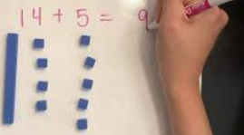
Bar Models
Bar models are used to support children in solving addition questions. They learn to use the language of part, part and whole.
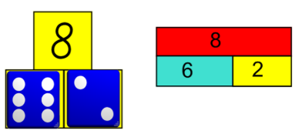
Number lines
They use number lines and practical resources to support calculations.

3 + 2 = 5
+1
+1

___________________________________________
0 1 2 3 4 5 6 7 8 9

Children then begin to use numbered lines to support their own calculations using a numbered line to count on in ones.

8 + 5 = 13
+1
+1
+1
+1
+1
0 1 2 3 4 5 6 7 8 9 10 11 12 13 14 15

Tens frames
Tens frames can be used to show addition using counters.

7 + 5 = 12

ADDITION
Y2
Base Ten
Children will use base ten to build numbers and add these together. They will start by using physical resources and then start to draw the representations when they are more confident.
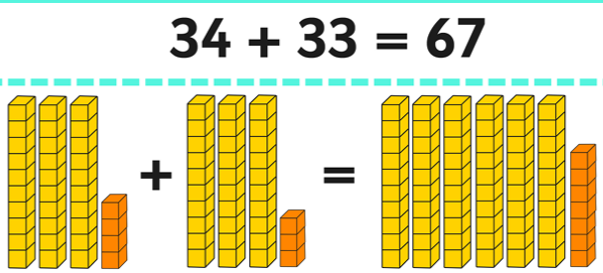
Children will begin to use ‘empty number lines’ themselves starting with the larger number and counting on.
Bar Models
Bar models are used to support children in solving addition questions. They continue to develop their understanding of parts and the whole.
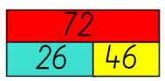
Counting on in tens and ones
34 + 23 = 57
+10
+10

+1
+1
+1

34 44 54 55 56 57

Adding the ones in one jump
34 + 23 = 57
+10
+10

+3

34 44 54 57

Adding the tens in one jump and the ones in another jump
34 + 23 = 57
+20
+3

34 54 57

Bridging through tens
37 + 15 = 52
+10
+2
+3

37 47 50 52

Children will begin to move on to the partitioning column method once they are secure with number lines.

 | 2 | 0 | + | 3 |  |  |  |  |  |  | 5 | 0 | + | 8
 | 3 | 0 | + | 4 |  |  |  |  |  |  | 4 | 0 | + | 3
 | 5 | 0 | + | 7 | = | 5 | 7 |  |  |  | 9 | 0 | + | 11 | = | 1 | 0 | 1

ADDITION
Y3

Children will continue to use empty number lines with increasingly large numbers, including compensation where appropriate.

Count on from the largest number irrespective of the order of the calculation

38 + 186 = 224
+30
+4
+4

186 216 220 224

Compensation

49 + 73 = 122
+50

-1

73 122 123

Column method
Children will begin to move on to the column method once they are secure with number lines. They will start with numbers that don’t require carrying and then move on to those that do. In Year 3, the children will be adding numbers with up to three digits.

621 783 367
+ 48 + 42 + 785
669 825 1152
¹ ¹ ¹ ¹

ADDITION
Y4

In Year 4, the children continue to practise the formal method of addition with carrying. They will be using numbers with up to four digits in different contexts. In this year, they will also be taught to estimate and use the inverse operation to check their answers.

1625 1500
+ 248 Using estimation to check: + 300
1873 1800
¹

Using similar methods, children will:
- add several numbers with different numbers of digits;
- begin to add two or more three-digit sums of money, with or without adjustment from the pence to the pounds;
- know that the decimal points should line up under each other, particularly when adding or subtracting mixed amounts, e.g. £3.59 + 78p.

Bar Models
Children will use bar models as a tool to represent addition problems to support their understanding.
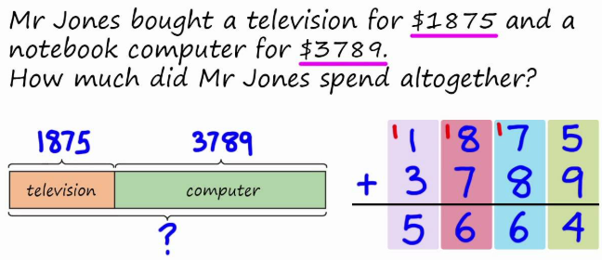

ADDITION
Y5
Children should extend the carrying method to numbers with more than four digits, including those with decimal numbers. In Year 5, the children need to be checking their answers using two different methods: the inverse and rounding to estimate.

 | 3 | 2 | 4 | 0 | 5 |  |  |  | £ | 2 | 3 | . | 5 | 9 |  |  |  | 1 | 9 | . | 0 | 1 | A zero needs to be used as a place holder.
+ |  | 9 | 3 | 4 | 9 |  |  |  | £ |  | 7 | . | 5 | 5 |  |  |  |  | 3 | . | 6 | 5
 | 4 | 1 | 7 | 5 | 4 |  |  |  |  | 3 | 1 | . | 1 | 4 |  |  |  |  | 0 | . | 7 | 0
 | 1 |  |  | 1 |  |  |  |  |  | 1 | 1 |  | 1 |  |  |  |  | 2 | 3 | . | 3 | 6
 |  |  |  |  |  |  |  |  |  |  |  |  |  |  |  |  |  | 1 | 1

ADDITION
Y6

In Year 6, the children continue to use the methods from Year 5 with increasingly difficult whole and decimals numbers. Once the children are secure in the calculation, they will be solving multi-step problems in contexts that require them to use the method to find an answer. Again, they must ensure that they check their answers using the inverse and rounding to estimate.

 | 1 | 0 | 3 | 9 | 8 |  |  |  |  | 2 | 3 | . | 3 | 6 | 1
+ |  |  | 4 | 2 | 6 |  |  |  |  |  | 9 | . | 0 | 8 | 0 | Zeros need to be used as place holders
 |  | 9 | 6 | 3 | 4 |  |  |  |  | 5 | 9 | . | 7 | 7 | 0
 | 2 | 0 | 4 | 5 | 8 |  |  |  |  |  | 1 | . | 3 | 0 | 0
 | 1 | 1 | 1 | 1 |  |  |  |  |  | 9 | 3 | . | 5 | 1 | 1
 |  |  |  |  |  |  |  |  |  | 2 | 1 |  | 2

