
St. Leonard’s CE Primary School
Division Policy

MENTAL CALCULATIONS

Doubling and halving - Knowing that halving is dividing by 2

Deriving and recalling division facts

Tables should be taught as frequently as possible from Y2 onwards. The children need to know the multiplication facts along with the related division facts.

Year 2 x2, x5, x10 times table

Year 3 x2, x3, x4, x5, x 8, x10 times table

Years 4, 5 and 6 All multiplication facts up to 12 x 12

Using and applying division facts
Children should be able to utilise their tables knowledge to derive other facts.
e.g. If I know 3 x 7 = 21, what else do I know?
30 x 7 = 210, 300 x 7 = 2100, 3000 x 7 = 21 000, 0.3 x 7 = 2.1 etc

Dividing by 10, 100 and 1000
Know the effects of dividing by 10, 100 and 1000:
10: digits shift one place to the right
100: digits shift two places to the right
1000: digits shift three places to the right

Use related facts
Given that 1.4 x 1.1 = 1.54
What is 1.54 ÷ 1.4, or 1.54 ÷ 1.1?

MANY MENTAL CALCULATION STRATEGIES WILL CONTINUE TO BE USED. THEY ARE NOT REPLACED BY WRITTEN METHODS.

DIVISION
YR and Y1

Children will understand equal groups and share items out in play and problem solving. They will count in 2s and 10s and later in 5s.

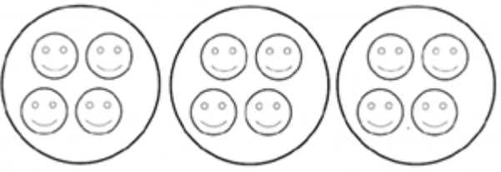12 shared between 3 is 4

DIVISION
Y2

Children will develop their understanding of division and use jottings to support calculation

Sharing equally
12 sweets shared between 3 people, how many do they each get?

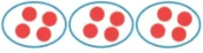

Grouping or repeated subtraction
There are 6 sweets, how many people can have 2 sweets each?

Repeated subtraction using a number line or bead bar
12 ÷ 3 = 4

0 1 2 3 4 5 6 7 8 9 10 11 12

3 3 3 3

The bead bar will help children interpret division calculations such as 10 ÷ 5 as ‘how many 5s make 10?’ The children will also be introduced to bar models which can also represent division problems.

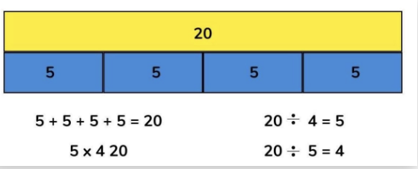

Using symbols to stand for unknown numbers to complete equations using inverse operations

÷ 2 = 4 20 ÷ = 4 ÷ = 4

DIVISION
Y3

Ensure that the emphasis in Y3 is on grouping rather than sharing.

Children will continue to use:

Repeated subtraction using a number line or counting stick.

Children should also move onto calculations involving remainders.

13 ÷ 4 = 3 r 1

4 4 4

0 1 5 9 13

Short division
Once the children are confident with grouping on a number line, they will be moved on to short division. At first, they will use numbers that will have no remainders at all, but once they show a good understanding of the process, they will be moved to questions where the remainder is carried to the next number.
 |  | 3 | 2
 | 3 | 9 | 6
 |  | 1  3 | 8
 | 4 | 7 | 2

Bar Models
Children use bar models to represent problems linked to division.

Using symbols to stand for unknown numbers to complete equations using inverse operations

26 ÷ 2 = 24 ÷ = 12 ÷ 10 = 8

DIVISION
Y4

In Year 4, the children will continue to practise short division with three-digit numbers divided by a one-digit number.
Answers should have no remainders at this stage.
 |  | 2 | 1  3 | 8
 | 4 | 8 | 7 | 2
 |  | 0  1 | 3  3 | 7
 | 5 | 1 | 8 | 5

DIVISION
Y5

In Year 5, the children will continue to practise short division with four-digit numbers divided by a one-digit number.
The children will be given questions with remainders now. Most division questions in this year group will be set in a real-life context, where the children need to consider the meaning of the remainder and how to express it, i.e. as a fraction, a decimal or as a rounded number depending on the context of the problem.
 |  | 0  5 | 6  5 | 6  2 | 3 |  | r | 5
 | 8 | 5 | 3 | 0 | 9
 |  | 0  5 | 9  5 | 9 | 0 |  | r | 2
 | 6 | 5 | 9 | 4 | 2

DIVISION
Y6

In Year 6, the children will continue to use written methods to solve short division using three and four-digit numbers by a single digit. However, in this year group, the focus is on teaching long division using a three-digit number by a two-digit number.

Short division
Short division in Year 6 consolidates what the children have learnt in Year 5. They will continue to have a mix of answers in decimals, fractions and rounded numbers.
 |  | 0  6 | 8 | 1  1 | 2 | .  1 | 1  2 | 2  4 | 5
 | 8 | 6 | 4 | 9 | 7 | . | 0 | 0 | 0

Long division

72 ÷ 3

3 ) 72
- 30 10x
42
The children will start off with smaller numbers until they become more confident with the method.
- 30 10x
12
- 6 2x
6
- 6 2x
0

Answer : 24
………………………………………………………………………………………………………………………………………………………………….

196 ÷ 6
32 r 4
They’ll then be taught to use more efficient steps e.g. 30 x 6 = 180. This will make the calculation a lot shorter for them.
6 ) 196
- 180 30x
16
- 12 2x
4

Answer : 32 r 4

972 ÷ 36
Once they fully understand the method, they’ll be asked to divide a three-digit number by a two- digit number. Again, the children must aim to use the fewest steps possible.
27
36 ) 972
- 720 20x
252
- 252 7x
0

Answer : 27

…………………………………………………………………………………………………………………………………………………………………….
87.5 ÷ 7

12.5
7 ) 87.5
If the children are very confident, they’ll be taught to use decimals in long division. Children should know that decimal points line up under each other.

- 70.0 10x
17.5
- 14.0 2x
3.5
- 3.5 0.5x
0

Answer : 12.5

