
St. Leonard’s CE Primary School
Subtraction Policy

MENTAL CALCULATIONS

Mental recall of addition and subtraction facts
10 – 6 = 4 17 - = 11
20 - 17 = 3 10 - = 2

Find a small difference by counting up
82 – 79 = 3

Counting back in repeated steps of 1, 10, 100, 1000
86 - 52 = 34 (by counting back in tens and then in ones)
460 - 300 = 160 (by counting back in hundreds)

Subtract the nearest multiple of 10, 100 and 1000 and adjust
24 - 19 = 24 - 20 + 1 = 5
458 - 71 = 458 - 70 - 1 = 387

Use the relationship between addition and subtraction
36 + 19 = 55 19 + 36 = 55
55 – 19 = 36 55 – 36 = 19

MANY MENTAL CALCULATION STRATEGIES WILL CONTINUE TO BE USED. THEY ARE NOT REPLACED BY WRITTEN METHODS.

SUBTRACTION
YR and Y1

Children are encouraged to develop a mental picture of the number system in their heads to use for calculation. They develop ways of recording calculations using pictures etc.

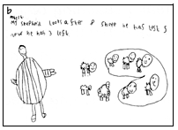
Base Ten
Children will use base ten to build numbers and take one amount away from another. They will start by using physical resources and then start to draw the representations when they are more confident.
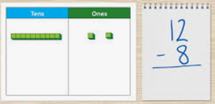
Bar Models
Bar models are used to support children in solving subtraction questions. They learn to use the language of part, part and whole.
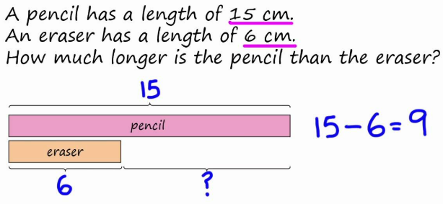
Number lines
They use number lines and practical resources to support calculation. Teachers demonstrate the use of the number line.

6 – 3 = 3
-1
-1
-1

___________________________________
0 1 2 3 4 5 6 7 8 9 10

The number line should also be used to show that 6 - 3 means the ‘difference between
6 and 3’ or ‘the difference between 3 and 6’ and how many jumps they are apart.

0 1 2 3 4 5 6 7 8 9 10

Children then begin to use numbered lines to support their own calculations - using a numbered line to count back in ones.

13 – 5 = 8
-1
-1
-1
-1
-1

0 1 2 3 4 5 6 7 8 9 10 11 12 13 14 15

Tens frames

Tens frames can be used to illustrate subtraction.

12 - 5 = 7

SUBTRACTION
Y2
Base Ten
Children will continue to develop their understanding of drawing the representations and subtracting an amount.
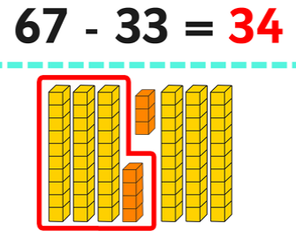

Bar Models
Bar models are used to support children in solving subtraction questions. They continue to develop their understanding of part, part and whole.
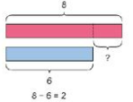
Children will begin to use empty number lines to support calculations.

Counting back
First counting back in tens and ones.
47 – 23 = 24

-1
-1
-1
- 10
- 10

24 25 26 27 37 47

Then helping children to become more efficient by subtracting the units in one jump (by using the known fact 7 – 3 = 4).
47 – 23 = 24
-10
-10
-3
24 27 37 47

Then they’ll subtract the tens in one jump and the units in one jump.
47 – 23 = 24
-20
-3
24 27 47

Bridging through ten can help children become more efficient.

42 – 25 = 17
-3
-20
-2

17 20 22 42

Counting on

If the numbers involved in the calculation are close together or near to multiples of 10, 100 etc, it can be more efficient to count on.

Count up from 47 to 82 in jumps of 10 and jumps of 1.

82 - 47
+10
+1
+1
+10
+10
+1
+1
+1

0 47 48 49 50 60 70 80 81 82

SUBTRACTION
Y3

Partitioning and decomposition

The numbers should be partitioned into place value columns and base 10 materials can be used to show the decomposition of the number.

189 = 100 + 80 + 9
- 57 50 + 7
100 + 30 + 2 = 132

Initially, the children will be taught using examples where both the tens and units digits are larger from the number being subtracted.

Exchanging
The children will then be taught to exchange using the same method.

171 =
- 146

Step 1 100 + 70 + 1
- 100 + 40 + 6
The calculation should be read as ‘1 take away 6’.

Step 2 100 + 60 + 11
- 100 + 40 + 6
0 + 20 + 5 = 25

This may be recorded by the children as
₆₀
100 + 70 + ¹1
100 + 40 + 6
0 + 20 + 5 = 25

Children should know that ones line up under ones, tens under tens, and so on.

Number lines
Where the numbers are involved in the calculation are close together or near to multiples of 10, 100 etc counting on using a number line should still be used.

102 – 89 = 13
+10

+1
+2

0 89 90 100 102

SUBTRACTION
Y4
Bar model
Continue to use column subtraction modelled with place value counters, objects, pictorial representations and the bar model method.
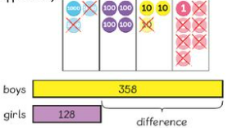

Partitioning and decomposition
The children should be secure with the partitioning method before moving on to the decomposition method in Y4.

2754 =
- 1286

Step 1 2000 + 700 + 50 + 4
- 1000 + 200 + 80 + 6

Step 2 2000 + 700 + 40 + 14 (adjust from Tens to Ones)
- 1000 + 200 + 80 + 6
Step 3 2000 + 600 + 140 + 14 (adjust from Hundreds to Tens)
- 1000 + 200 + 80 + 6
1000 + 400 + 60 + 8 = 1668

This would be recorded by the children as
₆₀₀ ₁₄₀
2000 + 700 + 50 + ¹4
1000 + 200 + 80 + 6
1000 + 600 + 60 + 8 = 1668

Decomposition

Children will move onto this method once they are secure with the partitioning method.

 | 7 |  | 4
 | 8 | 17 | 5 | 12
- | 4 | 9 | 3 | 6
 | 3 | 8 | 1 | 6

Number lines

Where the numbers are involved in the calculation are close together or near to multiples of 10, 100 etc, counting on using a number line should still be used.

511 – 197 = 314
+300

+11
+3

0 197 200 500 511

SUBTRACTION
Y5

Unless the children still require the partitioning method, they will mainly use the decomposition method in Y5 with increasingly larger numbers. The children also need to be checking their answers using two different methods: the inverse and rounding to estimate.

Decomposition

 |  | 8 | 13 |  |  |  |  |  |  |  |  | 6 | 10 |  | 8
 | 3 | 9 | 4 | 12 | 8 |  |  |  |  |  |  | 7 | 1 | 16 | 9 | . | 10
- |  | 7 | 6 | 5 | 4 |  |  |  |  |  | - |  | 3 | 7 | 2 | . | 5
 | 3 | 1 | 7 | 7 | 4 |  |  |  |  |  |  | 6 | 7 | 9 | 6 | . | 5

Number lines
Where the numbers are involved in the calculation are close together or near to multiples of 10, 100 etc counting on using a number line should still be used.

1209 – 388 = 821
+800

+9
+12

0 388 400 1200 1209

SUBTRACTION
Y6

In Year 6, the children will be subtracting with increasingly large and more complex numbers. Once the children are secure in the calculation, they will be solving multi-step problems in contexts that require them to use the method to find an answer. Again, they must ensure that they check their answers using the inverse and rounding to estimate.

Decomposition

A zero needs to be used as a place holder.
 | 0 | 14 | 9 |  |  |  |  |  |  |  |  | 0 | 9 |  |  | 3
 | 1 | 5 | 10 | 16 | 9 | 9 |  |  |  |  |  | 1 | 10 | 15 | . | 4 | 11 | 9 | Kg
- |  | 8 | 9 | 9 | 4 | 9 |  |  |  |  | - |  | 3 | 6 | . | 0 | 8 | 0 | Kg
 |  | 6 | 0 | 7 | 5 | 0 |  |  |  |  |  |  | 6 | 9 | . | 3 | 3 | 9 | kg

Number lines
Where the numbers are involved in the calculation are close together or near to multiples of 10, 100 etc counting on using a number line should still be used.

3002 – 1997 = 1005
+1000

+2
+3

0 1997 2000 3000 3002

